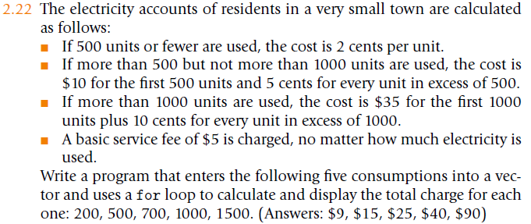

If-else statement, flow chart.

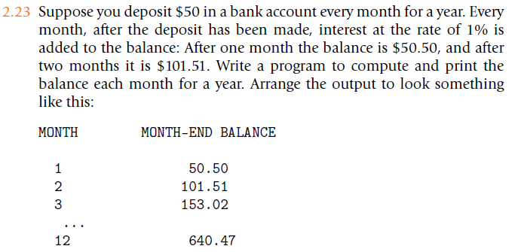

For loop statement

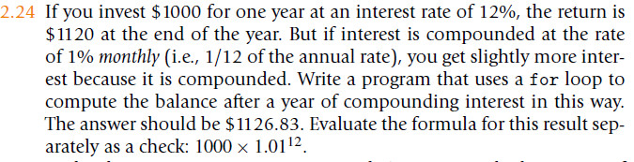

For loop statement, in-line function

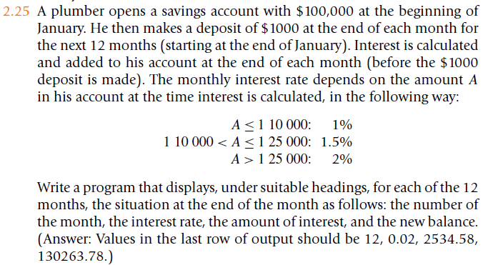

If-else statement, flow chart.

2.26 It has been suggested that the population of the United States may be modeled by the formula



where *t* is the date in years. Write a program to compute and display the population every ten years from 1790 to 2000. Try to plot a graph of the population against time as well. Use your program to find out if the population ever reaches a “steady state”

(i.e., stops changing).

Comparing p(t-1) with p(t) to check the steady state.

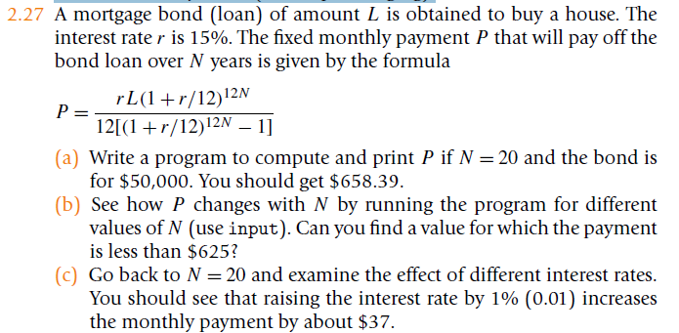

Change rate & N to build up a table. For loop, Output format.

